Gabriel Martinez-Amezaga, Kaz Tam, Gabriella Best, Andisha Safdariyan, Danish Safdariyan

MS3 Report

CS 3110: Data Structures and Functional Programming

May 16, 2024

**MS3 Report**

Vision

To reiterate what we reported in MS2 and MS1, we seek to create a niche calendar program that has various functions and a consistent, aesthetically pleasing, graphical user interface. We previously wanted to create a calendar that was a regular calendar, a task manager, and a schedule manager, but we reduced the workload to just the first two for the application. The regular calendar will include normal functionality such as creating repeating events or notating important dates. The task manager will be a normal task manager that keeps track of impending tasks. The purpose of this program is to provide a time management method that is easy to use and convenient as well.

Some of us within the group are currently frustrated with the different calendar and task management options available to us. More often than not, a calendar app does not encompass what we want to use out of it (ex: different views that include different events/schedules). Additionally, we want to combine this calendar functionality with an integrated task manager window in the program as well. The goal is to create a computer program for a task management system and organizational system that encompasses different uses and is simple to use.

We decided to name the program: *Trek*.

**MS3 Report Continued**

Summary of Progress

During MS1, we created a vision for what we want our program to do. For MS2, we wanted to do two essential things that would set the foundation for the rest of the project. First, we wanted to figure out a data structure to represent calendar data. Second, we wanted to find a GUI library that we would work with for the project. After experimenting with the OCaml graphics library and deciding it would not work long term, we settled on using Bogue. The link to Bogue is below: <https://github.com/sanette/bogue/blob/master/README.md>.

For MS3, we fully implemented all functionality that we had within our vision. First we implemented all calendar functionality and then the GUI that went along with it in Bogue. After implementing that functionality, we then proceeded to work on the event functionality within the calendar. Events could fill the calendar once, daily, weekly, monthly, and yearly. We also implemented a window in the GUI to add these events. Once we finished with events, we then started working on the task list. The task list can take as many tasks as the user wants and provides a list of those tasks for the user. Once the task list GUI was implemented, the user could click on any task and see what day a task is due.

Overall, the current implementation combines all of these features in a seamless manner. There are three parts to the window, each to do what was described above. This implementation is exactly what we wanted it to be, and we are proud of *Trek*.

**MS3 Report Continued**

Activity Breakdown

*Danish:*

* **Responsibilities:** Backend functionality. Collaborated primarily with Gabriella and Andisha to implement the backend development. My responsibility was completing all of the backend functions and testing necessary for implementing dates and most of the events for our calendar. In addition to [date] and [event], I also worked on [calendar] to integrate the event functionalities with the calendar.
* **Activities:** Group meetings.
* **Features:** All the features with [Date], most of the features on [Event], and a fair amount of [calendar]
* **Number of hours:** ~25 hours.

*Kaz:*

* **Responsibilities:** Front-end (GUI). Implementing GUI functionality (Calendar Display and Adding Events). Collaborated with Gabriel on front-end.
* **Activities:** Group meetings.
* **Features:** All features related to [MonthDisplay] compilation unit and [EventDisplay] compilation unit.
* **Number of hours:** ~35 hours.

**MS3 Report Continued**

Activity Breakdown

*Andisha:*

* **Responsibilities:** Collaborated primarily with Gabriella and Danish to implement the backend development. Contributed to implementing the calendar and event functionalities along with the test cases for them. Additionally implemented the coloring functionality for the backend. Implemented the time functionality which was showing the precise time of an event in hours and minutes, but we decided to not go further with using it. Additionally, worked on a different data structure and implemented almost all the necessary functionalities for the whole calendar considering the events, but did not end up using the data structure.
* **Activities:** Group meetings.
* **Features:** Coloring events, events, calendar, [CalDict] compilation unit functionality and implementation.
* **Number of hours:** ~22 hours.

*Gabriel:*

* **Responsibilities:** Front-end (GUI). Implementing GUI functionality (Task List Display and Save Functionality). Polishing GUI implementation and providing aesthetic design. Writing MS3 report. Collaborated with Kaz on front-end.
* **Activities:** Group meetings.
* **Features:** All features related to [TaskListDisplay] compilation.
* **Number of hours:** ~30 hours.

**MS3 Report Continued**

Activity Breakdown Continued

*Gabriella:*

* **Responsibilities:** Backend functionality. Collaborated primarily with Danish and Andisha to implement the backend development. Responsibilities: complete all of the backend functions and testing necessary for implementing tasks for our calendar. In addition to [task] and [taskList]. Additionally made modifications to [calDict]. While [task] and [taskList] were the core files for implementing tasks, functions in [calDict] needed to be added so that certain list features abstracted in [taskList] could be utilized.
* **Activities:** Group meetings.
* **Features:** All features related to [TaskList] compilation unit. Additionally, modified [CalDict] compilation unit functionality and implementation. Implemented testing as well.
* **Number of hours:** ~22 hours.

**MS3 Report Continued**

Productivity Analysis

Our team accomplished almost everything we wanted to during the period from MS2 to MS3. Unlike last time, there was not much uncertainty within the group toward finishing, but there was some frustration over communication. Once we improved our communication, the group worked well together and executed everything well. The majority of the group also had to balance final exams and final projects with this project, but in the end the group did so well. Overall, the only thing that we could not implement in time was the save functionality. We implemented new changes that exceeded the content being saved, and by the time we realized this, we did not have enough time to implement a fix. Thus, we removed the save functionality. However, we are still proud of the work we did, and we implemented a calendar that does exactly what our vision wanted it to do.

Please see the next page for a comparison of the past GUI interface with the current GUI interface.

**GUI Examples**

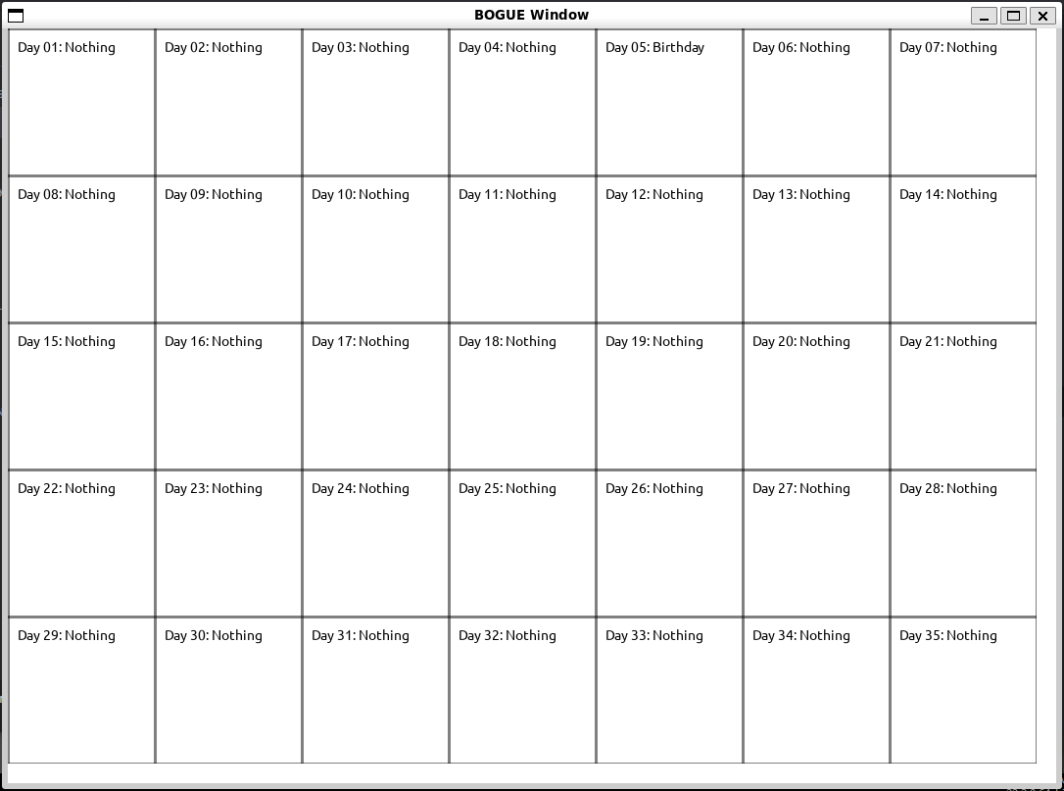*Past GUI Example:*

*Current GUI Example:*